BILLIE JEAN KING CUP 2025 ASIA / OCEANIA IN KUALA LUMPA REPORT
By Cyril Jacobe
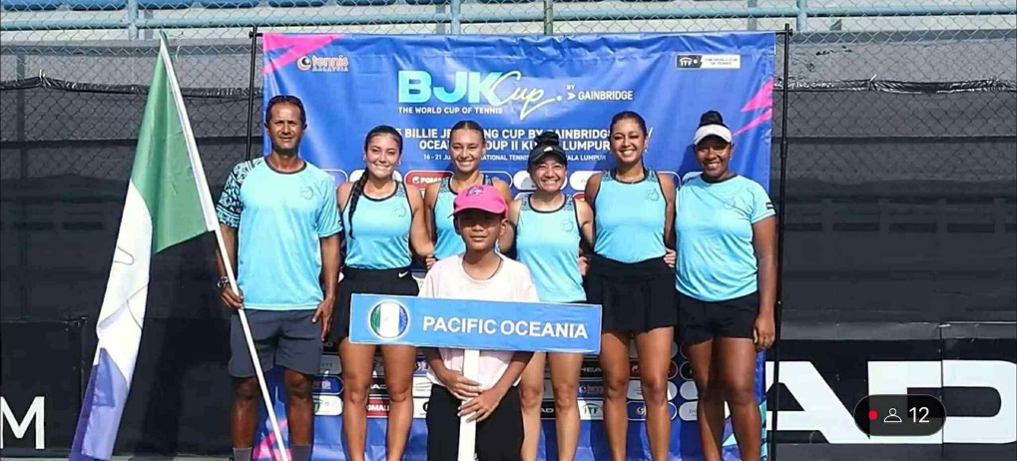

First of all, I want to thank the Oceania Tennis Federation for having given me the opportunity to captain the Pacific Oceania Ladies during the BJKC 2025 in Malaysia. It’s a unique experience for our regional players which drives better training and competition calendars. I felt honored to mentor our ladies during the entire duration of the trip.
The team was composed of 4 players and a vice captain
Players: Carolann Delaunay (New Caledonia), Violet Apisah (PNG), Patricia Apisah (PNG), Litiana Godinet (American Samoa),
Vice-Captain: Abigail Tere Apisah (PNG)
I was first to arrive in Kuala Lumpur on the 13th June 2025 and our ladies followed on that same evening with Carolann arriving the morning of the 14th June. We had 2 days to acclimatize and regroup the team and bond. Personally, I think having a minimum of 3 full days could help our ladies especially when they’re all flying from cooler and non-tropical climates.
Having the assistance of Abigail was very useful. She has the caliber to lead or co lead the team. In my opinion, having a team of 2 staff brings a better energy and incredible atmosphere to the team. To be considered for the next ties.
The technical meeting was held on Sunday 2pm. All coaches and or captains were present for the meeting. Teams present were:
Mongolia, Philippines, Indonesia, Pacific Oceania, Uzbekistan, Iran, Norther Mariana Islands, Malaysia, Singapore and Kyrgyzstan.
The format was 2 pools of 5 teams with Group A and B
Pacific Oceania was in pool B with Indonesia, Uzbekistan, Iran, Philippines. It was known from the moment it was drawn as the pool of “HELL”.
The pool matches were held on the Monday, Tuesday, Wednesday, Thursday and Friday with a day off. Saturday was reserved for the semi-finals which would determined the positions and the relegation and promotion.
On Monday we played versus Iran:
We won 2-1. Violet dominated at #2 singles while Carolann should have won but her injured foot was the detriment. In doubles the Apisah sisters took care of business and brought us the win.
On Tuesday we played Indonesia:
We lost 2-1. Violet once again was a machine and cleaned a win in 2 sets bringing confidence to PO. Carolann once again struggled with her injury but she was by far the better player to put in at #1 as I felt the other two reserves were not mentally in shape to compete at the level required. Nonetheless she loses in straight sets 2and 2. Our doubles could have gone our way with a super tie 10-7 down. Taking the first set 6-4 was reassuring but the momentum switched.
On Wednesday was our day off:
I had organized a serious recovery day with Yoga in the morning followed by a massage at midday then a light hit in the afternoon and ended with an ice bath for all team members. It really helped the girls rejuvenate new cells and a new mind.
On Thursday we played Uzbekistan:
We won 2-1. Violet began with a win for PO but struggled to find momentum in the first set clenching 7-6. In the second set, she was on point and destroyed her opponent 6-0. Carolann once again struggled but played better… nonetheless losing 2 and 2. Couldn’t seem to play during the match. We were quite disappointed because her foot was too much of an excuse.
In doubles, the sisters brought us to edge of our seats. Having 7 match points and winning on the 8th in a 3rd set super 11-9. In my opinion, we should have won in straight sets but there was a lack of positive energy during the crucial points. It’s tennis and in ladies’ doubles, anything is possible due to pressure.
On Friday it was against Philippines:
We lost 2-1 but we should have won that tie. Violet kicked off with a 6-2 6-0 win. She bullied her opponent off the court. Even their team manager was amazed. Carolann played her best tennis of the week. She was able to jump during her serves and move better. Her foot didn’t affect her as much that day. I was so proud of her even if she thought that she was capable of playing better. It was a thriller 3 setter. The doubles was disappointing because we were so close to the goal but yet we lost. The philippino pair were very active and dynamic which created confusion in our sisters. 7-6 6-7 8-10 with 2 match points.
This match took everything we had. We were so upset and disappointed that we couldn’t get ourselves to talk at the dinner table. It was the end! Having won this match then we were playing Mongolia for a promotion hope.
On Saturday we were up against Kyrgyzstan:
We lost 2-1. Litia was up at #2 singles. She lost but couldn’t play as her nerves took control. She was very negative with herself and couldn’t get the ball rolling. Carolann then felt the pressure to win to keep PO alive. She began worst than ever but managed to gather some positive thoughts and levels the match. In the 3rd set the heat and fatigue got to her therefore struggled and lost 4 games in a row. I put Patricia and Litia in doubles to conquer 1 win for PO and so they did 6-3 6-3.
We finished 6th but we were contenders to win the promotion because we had many chances during our last pool match.
We were very unfortunate with the lead up prior to the BJKC with Carolann getting seriously injured in Monastir on her foot 3 weeks before the trip. She just couldn’t jump on her serve as you may have seen in the livestreaming matches. She also had difficulty pushing towards the backhand side, even worst having to recover from the left side. The forward movement as well was painful as she had to stretch the achilles tendon while doing it. With a weak physical game comes a weakened mental game and we had to dig very deep on each match to bring the best of her. I believe with Carolann in top shape the team would have had a lot more odds. We were all in the unknown until 2 days prior which didn’t give the team the assurance needed to perform efficiently. To add to this, there was also the tardy passport renewal of Violet and Patricia, thank you to Richard Breene for putting pressure for that to happen 2 days before departure for Kuala Lumpur.
I would recommend that the OTF make the #3 and or #4 players of the team aware that there’s no guarantee that they will be playing a match during the trip. The team’s top goal is to win and get the promotion and therefore the captains will need to choose the best players on the day to conquer. Each player must be ready physically and mentally for these scenarios and most importantly accept the captains’ decisions regarding daily nominations. Of course, as long as there’s a good dialogue between the captains and the players.
In addition, personally, I was very pleased to have a vice Captain during the trip especially with Abigail Tere Apisah. Having her background and expertise was advantageous in so many ways. She was professional and present with us at all times. It was extremely positive to have her share her past tennis stories while on tour since the players could relate to. I suggest to have 2 captains for the future because it gives a better chemistry within the team especially at the management level.
Noticeably, Violet was our main player and without her we would have ended even lower. She is a true competitor and contender at this level of the BJKC. Her #2 seat was crucial since she guaranteed us a win and an advantage in the second singles match. It gave Carolann a boost for her singles but unfortunately with her foot injury we couldn’t make the most Violet’s wins. Fortunately, the team could rely on Violet and Patricia for the deciding doubles and demonstrate a high level of doubles no matter the adversary.
We had a special request from our players regarding the uniforms. They preferred singlet tennis tops instead of the shirts especially in these hot and humid nations.
Obviously, for Pacific Oceania to remain a contender for the hot promotional seats we must ensure that all 4 players have an active competition schedule prior to the BJKC trips. All the teams’ top 2 players present at the BJKC 2025, apart from Northern Mariana Island, either had a WTA ranking, played ITF events or had an active collegiate schedule. From these competition calendars we should already have an estimation of the final standing post BJKC.
Once again, I want to thank the Oceania Tennis Federation for having given me the opportunity to captain the Pacific Oceania Ladies during the BJKC 2025 in Malaysia. It was a unique experience for me and I am grateful. I felt honored to mentor our ladies during the entire duration of the trip and to top it all, our players are very special humans with a massive heart and the island spirit.
